1. SQL Server
SQL Server is a Relational Database Management System (RDBMS) developed by Microsoft for storing, managing, and retrieving data.
SQL Server Editions
- Express – Free, limited features.
- Standard – Suitable for medium-sized applications.
- Enterprise – Advanced features for large organizations.
- Developer – Free for development and testing.
Key Components
- Database Engine – Stores and processes data.
- SQL Server Agent – Schedules jobs and tasks.
- SSMS (SQL Server Management Studio) – GUI tool for database management.

2. Window Functions
- Window functions perform calculations across a set of rows without grouping them.

OVER ()
- Defines the window or set of rows on which a function operates.

PARTITION BY
- Divides rows into groups while keeping individual rows visible.

ROW_NUMBER ()
- Assigns a unique number to each row.

RANK ()
- Assigns ranks to rows. Equal values get the same rank, and ranks are skipped afterward.
- DENSE_RANK ()
- Assigns ranks without skipping numbers.

3. GROUPING SETS, ROLLUP, CUBE
GROUPING SETS
Generates multiple grouping combinations in one query.
ROLLUP
Creates hierarchical subtotals and a grand total.
CUBE
Generates all possible subtotal combinations and grand totals.

4. Common Table Expression (CTE)
A CTE is a temporary named result set that exists only during query execution.
Advantages
- Improves readability.
- Simplifies complex queries.
- Useful for recursive operations.
Recursive CTE
A CTE that references itself.
Used for:
- Employee-manager hierarchy.
- Tree structures.
- Generating sequences.

5. MERGE Statement
MERGE combines INSERT, UPDATE, and DELETE operations into a single statement.
Benefits
- Reduces code complexity.
- Improves synchronization between tables.
- Better performance than multiple statements.

6. PIVOT and UNPIVOT:
- PIVOT
- Converts row values into columns.
- EXAMPLE:
- Department | Salary
- Becomes
- HR | IT | Sales
- UNPIVOT
- Converts columns back into rows.

7. Views:
A View is a virtual table created from a SQL query.
Advantages
- Simplifies complex queries.
- Provides data security.
- Hides sensitive columns.
Types of Views
- Simple View
- Complex View
- Indexed View
Indexed View
A view with a clustered index that stores data physically for faster access.

8. Indexes:
Indexes improve data retrieval speed.
Clustered Index
- Stores data physically in sorted order.
- Only one clustered index per table.
Non-Clustered Index
- Separate structure pointing to table data.
- Multiple non-clustered indexes allowed.
Covering Index
Contains all columns required by a query.
Index Fragmentation
Occurs when index pages become disorganized, reducing performance.
Query Optimization
Process of improving query execution speed by:
- Using indexes.
- Avoiding unnecessary columns.
- Writing efficient joins.

9. Stored Procedures:
A Stored Procedure is a precompiled collection of SQL statements stored in the database.
Benefits
- Faster execution.
- Reusable code.
- Improved security.
- Easier maintenance.
Types
- User-defined
- Temporary
- System
- Extended Stored Procedures
Features
- Accept parameters.
- Return values.
- Execute business logic.

10. User Defined Functions (UDF)
Functions are reusable database objects that return a value.
Benefits
- Code reusability.
- Modular programming.
- Easier maintenance.
Types
Scalar Function
Returns a single value.
Table-Valued Function
Returns a table.
System Function
Built-in SQL Server functions.
Examples:
- COUNT ()
- SUM ()
- GETDATE ()

11. Triggers
A Trigger is a special stored procedure that automatically executes when a database event occurs.
Uses
- Auditing.
- Validation.
- Logging changes.
Types
AFTER Trigger
Executes after INSERT, UPDATE, or DELETE.
INSTEAD OF Trigger
Executes instead of the triggering action.
LOGON Trigger
Executes when a user logs into SQL Server.
Advantages
- Automatic execution.
- Enforces business rules.
Disadvantages
- Can affect performance.
- Harder to debug.

12. Cursors:
A Cursor processes records one row at a time.
Life Cycle
- Declare
- Open
- Fetch
- Close
- Deallocate
Uses
- Row-by-row processing.
- Complex calculations.
Limitations
- Slow performance.
- High memory usage.
Alternatives
- Joins
- CTEs
- Window Functions

13. Exception Handling:
Exception handling manages runtime errors.
Types of Exceptions
System Defined
Generated automatically by SQL Server.
Examples:
- Divide by zero.
- Constraint violation.
User Defined
Created by developers.
TRY...CATCH
Handles errors gracefully.
THROW
Generates a new exception.
RAISERROR
Raises custom error messages.
Benefits
- Prevents application crashes.
- Improves debugging.

14. Transactions:
A Transaction is a group of SQL operations executed as a single unit.
ACID Properties
Atomicity
Either all operations succeed or all fail.
Consistency
Database remains valid before and after transaction.
Isolation
Transactions do not interfere with each other.
Durability
Committed changes are permanently saved.

Transaction States:
- Active
- Partially Committed
- Committed
- Failed
- Aborted

Transaction Management Statements:
BEGIN TRANSACTION
Starts a transaction.
COMMIT
Saves changes permanently.
ROLLBACK
Undoes changes.
SAVEPOINT
Creates a rollback checkpoint.

Implicit vs Explicit Transactions:
Implicit Transaction
SQL Server automatically starts transactions.
Explicit Transaction
Developer manually controls transactions.

Locking and Blocking:
Locking
Prevents simultaneous conflicting access to data.
Blocking
Occurs when one transaction waits for another to release a lock.

Deadlock:
A deadlock occurs when two transactions wait for each other indefinitely.
Example:
- Transaction A locks Table X and waits for Table Y.
- Transaction B locks Table Y and waits for Table X.
SQL Server automatically detects and resolves deadlocks by terminating one transaction.

HANDS ON:
EXERCISE 1: Ranking and Window Functions Goal:
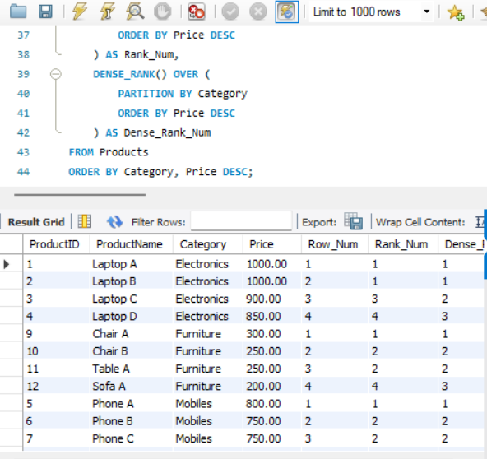
Use ROW_NUMBER (), RANK (), DENSE_RANK (), OVER (), and PARTITION BY. Scenario: Find the top 3 most expensive products in each category using different ranking functions. Steps: 1. Use ROW_NUMBER () to assign a unique rank within each category. 2. Use RANK () and DENSE_RANK () to compare how ties are handled. 3. Use PARTITION BY Category and ORDER BY Price DESC.

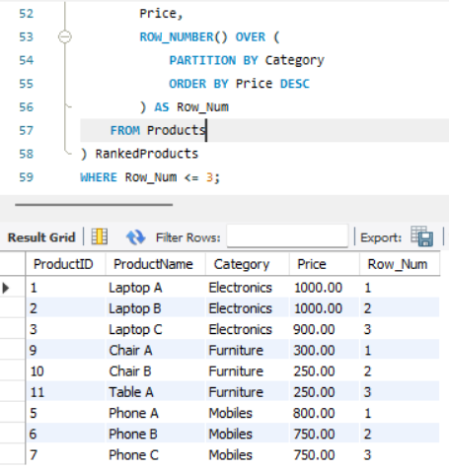

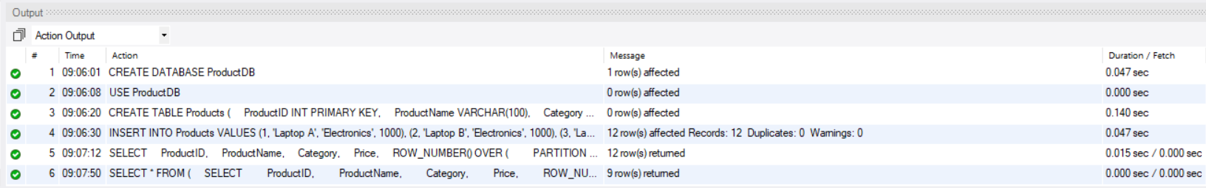

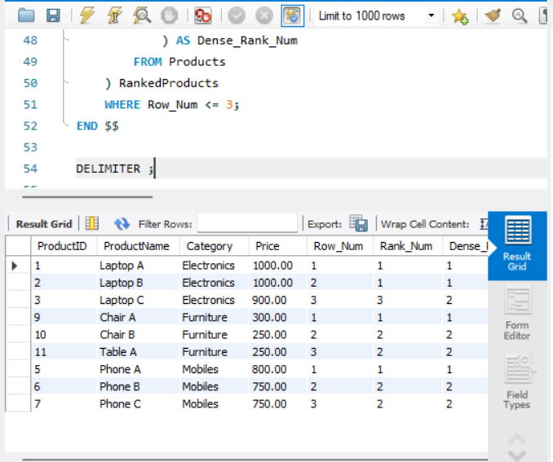
EXERCISE 1: Create a stored product:

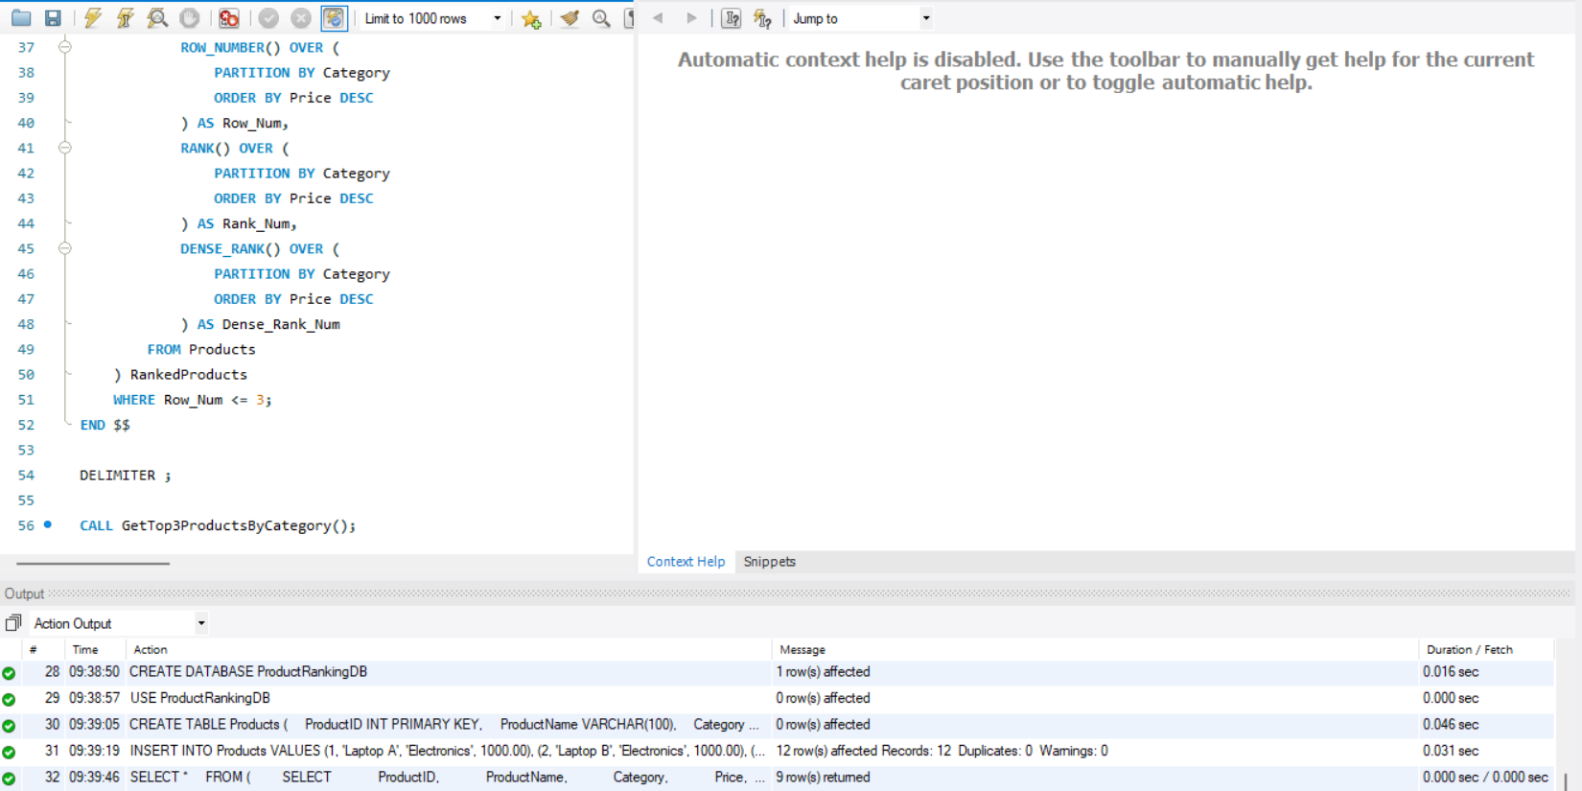

EXERCISE 5:
Return Data from a Stored Procedure:

